**Sprint 1 Plan**

**Meme Feed**

**Meme Teme**

**2/26/19**

**Revision 0**

**Goal:**

For this sprint, our goal is to tune out the kinks in our application and get ready for apple store deployment

**Task Listing:**

(1) As a user, I want to be able to see a Friend Feed which displays memes my friends liked. **(6)**

* Pull memes from firebase that the user’s friends have liked and sort them in chronological order. **(6)** *(Zac)*

(2) As a User, I want to be able search and look up someone else’s page, to see only their content **(10)**

* Implement the firebase functionality of the search typing a name (or user name) and the results being calculated. **(7)** *(Jon)*
* Rendering results on each letter entered. **(3)** *(Jon)*

(3) As a user I want to be able to see where a user found a photo they liked **(8)**

* When reacting a meme save who posted the meme they reacted to in firebase. (have it be a field called “likedFrom” ) **(4)** *(Siddhi)*
* When viewing a meme show either (from reddit) or (P’(P) liked from P’) or (P’(P) liked from reddit) Both should be able to clicked **(4)** *(Emma)*

(4) As a user I want comments to be intuitive and easy to navigate so that way the app is easy to use **(8)**

Be able to click anywhere on the comment button (be able to click somewhere that isn’t the bottom corner) **(3)** *(Emma)*

Implement lazy load of comments (first load the first 10 comments and then have a load more button that loads ten comments every time until no more comments can be viewed) **(5)** *(Siddhi)*

(5) As a user I want the ability to click on a meme in grid view and be shown all the information about the meme in order to react and better interact with it **(6)**

* When clicking on a meme in ANY grid view show the tile **(2)** *(Zac)*
* When clicking on a meme from grid and exiting from the tile save location of scroll so that way the user is in the same position of where they left (using a stack navigator) and passing the values between gridview component and this feed component **(4)** *(Zac)*

(6) As a user I want to have a visually pleasing user profile so that way it is easy to use **(4)**

* Change the location of user settings button for “p” profile **(2)** *(Siddhi )*
* Change the location of follow/unfollow button for “p`” profile **(2)** *(Siddhi)*

(7) As a user I want to be able to get to another user’s profile without searching them in order to make the use of the app more intuitive **(2)**

* Add username routing to every possible place **(2)** *(Emma)*

(8) As a user I want my profile to reflect my likes so that way I can see the memes I have already liked **(1)**

* Show memes with list and grid view (be sure that when you click on them they have all the functionality of user story 5)  **(1)** *(Zac)*

(9) As a developer I want to have better use of modularity to reduce technical debt **(12)**

* Create component ListView, with all the previous functionality and the functionally mentioned in this sprint  **(3)** *(Mia)*
* Create component GridView, with all the previous functionality and the functionally mentioned in this sprint  **(3)** *(Mia)*
* Create component TileScreenView, with all the previous functionality and the functionally mentioned in this sprint  **(3)** *(Mia)*
* Change out all of these components throughout the files so in friendfeed, home feed, userfeed, etc…  **(3)** *(Mia)*

(10) As a user I want to ensure I have a wide variety of current memes in order to have relevant funny content **(6)**

* Add more categories from the pulling reddit thread, everyone add 10 unique subreddits at a minimum  **(2)** *(Everyone)*

Edit script to not pull redundant content **(2)** *(Zac)*

* Test the pulling from reddit every 12 hours and see if the app self uploads.  **(2)** *(Mia and Zac)*

**Team Roles:**

**Mia:** Product Owner, Developer

**Emma:**  Developer

**Siddhi:**  Developer

**Zach:**  Developer

**Jon:** Scrum Master, Developer

**Initial Task Assignment:**

**Mia:**

(9) As a developer I want to have better use of modularity to reduce technical debt **(12)**

* Create component ListView, with all the previous functionality and the functionally mentioned in this sprint  **(3)** *(Mia)*
* Create component GridView, with all the previous functionality and the functionally mentioned in this sprint  **(3)** *(Mia)*
* Create component TileScreenView, with all the previous functionality and the functionally mentioned in this sprint  **(3)** *(Mia)*
* Change out all of these components throughout the files so in friendfeed, home feed, userfeed, etc…  **(3)** *(Mia)*

**Emma:**

(3) As a user I want to be able to see where a user found a photo they liked **(8)**

* When viewing a meme show either (from reddit) or (P’(P) liked from P’) or (P’(P) liked from reddit) Both should be able to clicked **(4)** *(Emma)*

(4) As a user I want comments to be intuitive and easy to navigate so that way the app is easy to use **(8)**

Be able to click anywhere on the comment button (be able to click somewhere that isn’t the bottom corner) **(3)** *(Emma)*

(7) As a user I want to be able to get to another user’s profile without searching them in order to make the use of the app more intuitive **(2)**

Add username routing to every possible place **(2)** *(Emma)*

**Siddhi:**

(3) As a user I want to be able to see where a user found a photo they liked **(8)**

* When reacting a meme save who posted the meme they reacted to in firebase. (have it be a field called “likedFrom” ) **(4)** *(Siddhi)*

(4) As a user I want comments to be intuitive and easy to navigate so that way the app is easy to use **(8)**

Implement lazy load of comments (first load the first 10 comments and then have a load more button that loads ten comments every time until no more comments can be viewed) **(5)** *(Siddhi)*

(6) As a user I want to have a visually pleasing user profile so that way it is easy to use

* Change the location of user settings button for “p” profile **(2)** *(Siddhi )*
* Change the location of follow/unfollow button for “p`” profile **(2)** *(Siddhi)*

**Zac:**

(1) As a user, I want to be able to see a Friend Feed which displays memes my friends liked. **(6)**

* Pull memes from firebase that the user’s friends have liked and sort them in chronological order. **(6)** *(Zac)*

(5) As a user I want the ability to click on a meme in grid view and be shown all the information about the meme in order to react and better interact with it **(6)**

* When clicking on a meme in ANY grid view show the tile **(2)** *(Zac)*
* When clicking on a meme from grid and exiting from the tile save location of scroll so that way the user is in the same position of where they left (using a stack navigator) and passing the values between gridview component and this feed component **(4)** *(Zac)*

(8) As a user I want my profile to reflect my likes so that way I can see the memes I have already liked **(1)**

* Show memes with list and grid view (be sure that when you click on them they have all the functionality of user story 5)  **(1)** *(Zac)*

(10) As a user I want to ensure I have a wide variety of current memes in order to have relevant funny content **(6)**

* Add more categories from the pulling reddit thread, everyone add 10 unique subreddits at a minimum  **(2)** *(Everyone)*
* Edit script to not pull redundant content **(2)** *(Zac)*
* Test the pulling from reddit every 12 hours and see if the app self uploads.  **(2)** *(Mia and Zac)*

**Jon:**

(2) As a User, I want to be able search and look up someone else’s page, to see only their content **(10)**

* Implement the firebase functionality of the search typing a name (or user name) and the results being calculated. **(7)** *(Jon)*
* Rendering results on each letter entered. **(3)** *(Jon)*

**Initial Burn Up Chart:**

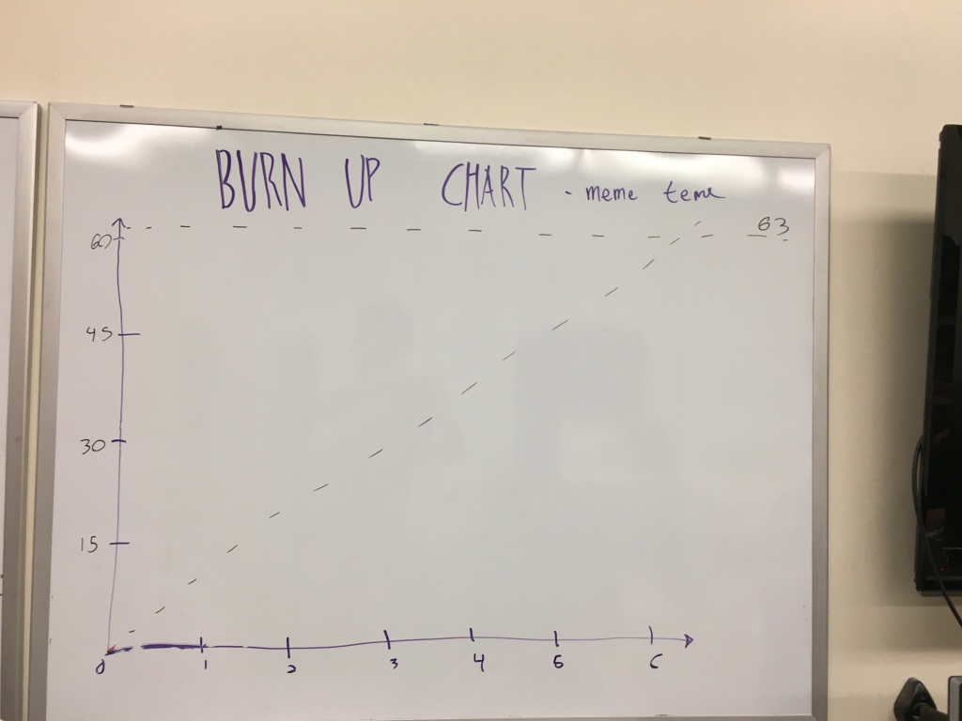

**Initial Scrum Board:**

